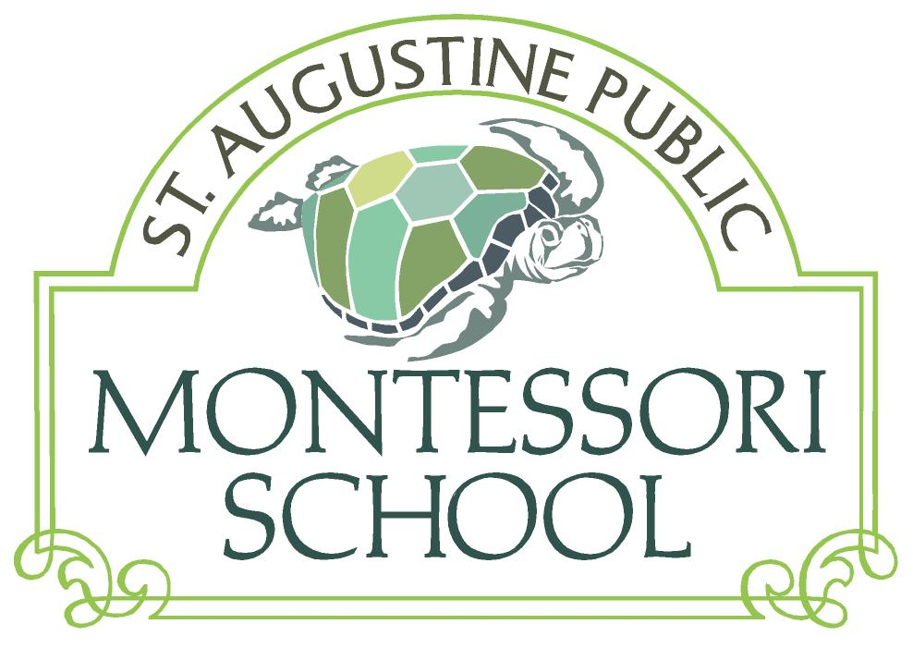

Dear Montessori Families,

After the beginning of the school year comes the launching of the St Augustine Public Montessori School (SAPMS) annual fund.

As a public charter school SAPMS receives funding from the Florida Education Finance Program (FEFP) based on the number of full-time students enrolled. As with all Florida public schools, we have had to make difficult choices to meet increasing state requirements without additional funding.

Our small charter school faces additional challenges. A school of 94 students does not have the advantages of scale that traditional or larger charter schools have. Other challenges result from our infancy as a school. Some of you have recently experienced the demands of preparing new classrooms to accommodate a modest increase in our student numbers. Facility and equipment costs will continue to increase as we continue our efforts to increase our student numbers and provide an adequate facility. To meet our current budget, we need $60,000 raised independently.

**Families are not required to contribute financially. However, we DO NEED YOUR help!** We ask each family to contribute what they can in direct, private donations. Based on the percentage of families that have donated to the annual fund in the past, we are asking $1,000 per child to meet our goal. If you are able and willing to contribute that amount, thank you very much! If you cannot contribute that amount, please consider a contribution that is within your means. A monthly donation is an option.

Contributions from friends and family (local or remote) are also welcome. See More Information for links to donation instructions and request templates.

Additional parent and board sponsored funding efforts will continue throughout the year. If we exceed our goal, we can do more!

As a former Montessori student put it, **“My years in Montessori were the best education I ever had!”** Let’s make sure our children feel the same way.

**“Free the child’s potential and you will transform him into the world.” - Maria Montessori**

How do you assign a value to your children’s education? Is there any way you can put a price on seeing your children becoming the people they are meant to be?

7 Williams Street  
St. Augustine, FL 32084

904-342-5350

Fax: 904-342-5354

staugustinemontessori.com

[Donation Instructions](http://www.staugustinemontessori.com/files/2015-16AnnualFund/SAPMS_AF_2015_16_Donation_Details.pdf)

[Donation request template](http://www.staugustinemontessori.com/files/2014-15AnnualFund/2014-15_Donation_Request_Template.doc)

[Business donation template](http://www.staugustinemontessori.com/files/2014-15AnnualFund/2014-15_Business_Donation_Template.doc)

[2015-16 SAPMS Budget](http://www.staugustinemontessori.com/files/2015-16AnnualFund/SAPMS_AF_2015_16_Budget.pdf)

## More information

## Bare-bones Budget

$698,000.00

## District Revenue

$647,000.00

## Annual Fund Goal

$60,000 (8.5%)

Annual Fund

2015-16